Newsletter

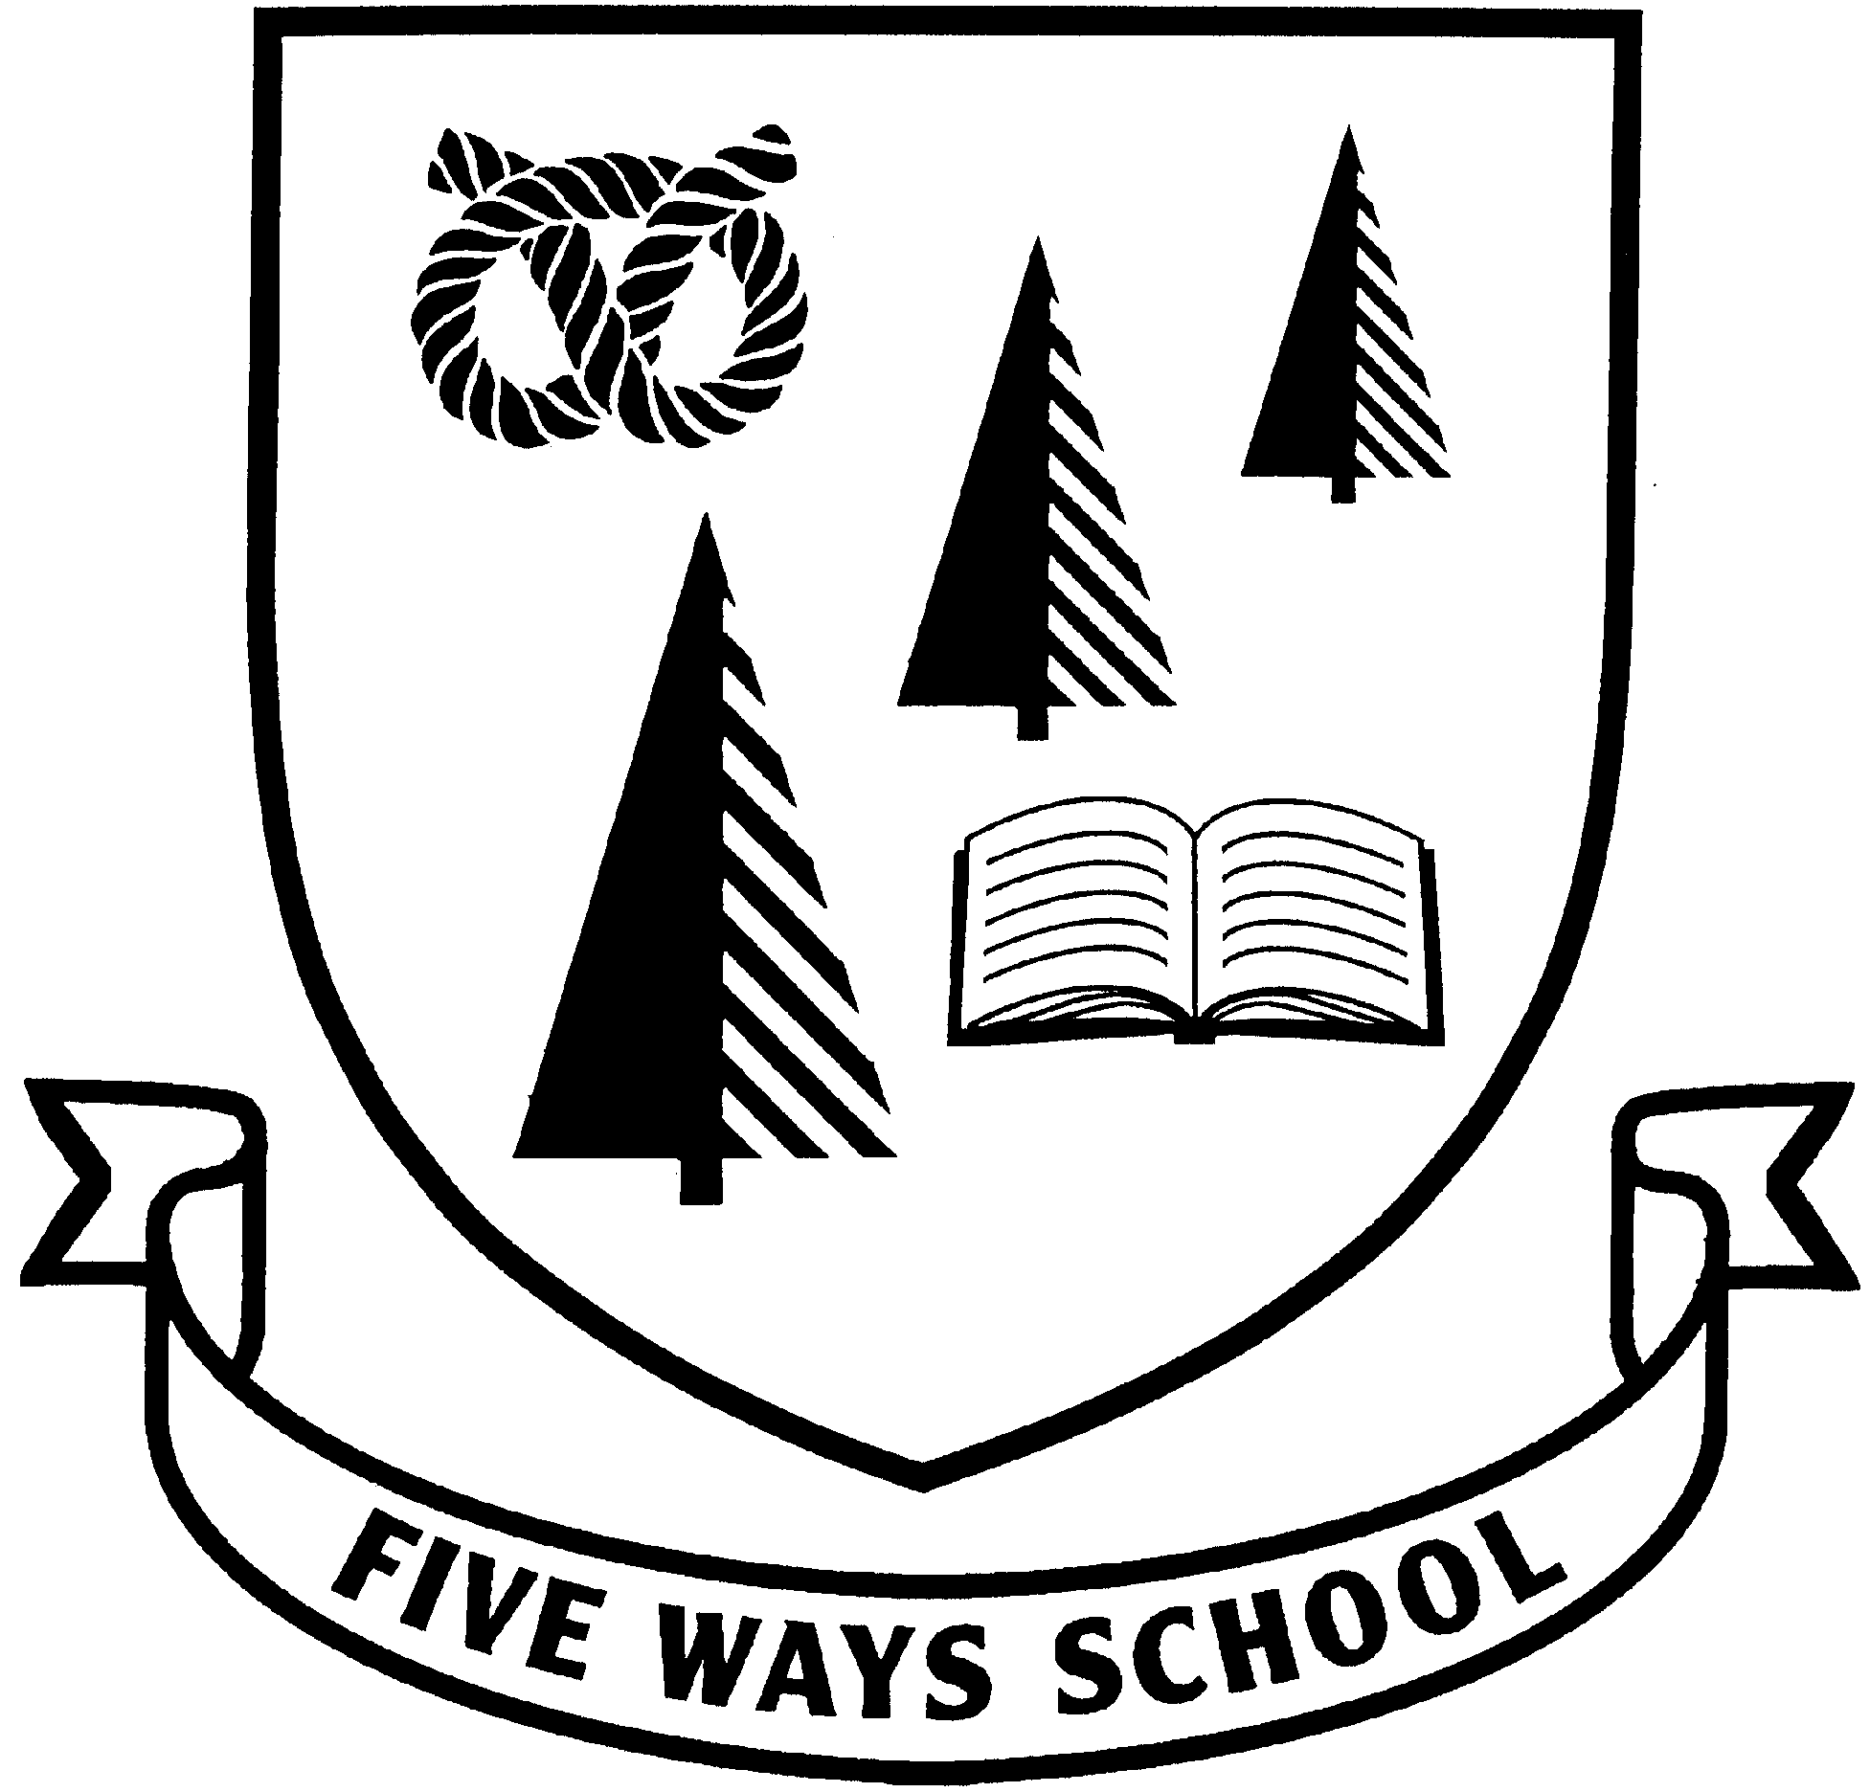

**Mrs R. Mander - Headteacher 27th September 2024**

**Forthcoming Dates:**

**Week beginning**

**30th September 2024 –**

**Menu week 2.**

1st October - PTFA AGM – 7.15pm KS1 Staffroom – *All welcome.*

10th October – Young Minds ‘Hello Yellow’ / World Mental Health Day

11th October- Sibling Photographs – Tempest Photographers

W/B 14th October - Parent/Teacher Consultations *(Face to Face After School Appointments)*

17th October- Foundation Stage, Key Stage 1 and Key Stage 2 Parents’ Evening Consultation Appointments 6.00pm – 8.30pm

25th October - School Closes for Half Term *(Normal Times)*

4th November - School Opens for staff and pupils

W/B 11th November - Anti-Bullying Week *(More details to follow)*

12th November – PTFA Meeting – 7.15pm KS1 Staffroom – *All Welcome*

15th November - Children in Need Day *(More details to follow)*

22nd November - Enrichment Day - International Day *(More details to follow)*

3rd December Year 3 & Year 4 Theatre Trip (Wolverhampton Grand Theatre – Beauty and the Beast)

5th December – Reception Christmas Service – 2.15pm KS1 Hall

6th December – Reception Christmas Service – 10.00am KS1 Hall

*Further dates will be added to the Newsletter as we progress through the year.*

**Harvest**

Pupils at Five Ways learn about Harvest

Festivals and the positive impactthey can have

upon caring for others that live in our community.

For this reason, I would like to ask families to

support our annual Harvest Fundraising

Campaign by donating food that will be distributed to the local community by Pastor John Tyrell and his volunteers. Suitable items to donate include tinned meat, tinned vegetables, tinned soup, long-life milk, pasta/rice pots and pasta sauces etc. All donations will be displayed in our Art Gallery for pupils to see before being passed to Mr Tyrell to distribute. Please send any donations into school with your child by **24th October** and their classteacher will arrange for them to be sent to the gallery to be displayed. Any donations will be much appreciated and will

really make a big difference to local people in need. Thank you for your support.





**Scooters and Bikes**

This is a reminder that scooters or any type of bikes are not permitted to be used on our school premises at drop off and collection times. This is due to the number of people on site during these times and the safety of everyone. Please also be aware that we do not have the facilities in school

to store scooters or bikes, so they should not be

left on the premises during the day.

**Non-Uniform Date Change**

Please note a change of date for non-uniform day. Non-uniform day will no longer take place on Friday 25th October and will now take place on Friday 20th December instead.

**Top Gate Leading to Chaplain Road** Due to recent weather conditions, parents and pupils are encouraged to stick to the main paths leading to and from the top gate. The grass bank and field is now very wet and slippery and there have been instances of people falling.

**Five Ways Primary School**

Langholm Drive

Heath Hayes, Cannock, WS12 2EZ

Web Site Address: **www.fiveways-primary-school.org.uk**

Tel No: 01543 278071 Email: [office@fiveways.staffs.sch.uk](mailto:office@fiveways.staffs.sch.uk)

**Walk to School Month**

Every October it is International Walk to School Month which provides an

opportunity for children to join hundreds of thousands of pupils across the

globe, celebrating the walk to school. Staffordshire County Council support

this campaign and as a school, we too, want to promote healthy lifestyles and

encourage more pupils to walk to school.

For this reason, we are encouraging pupils and parents to take part in Walk to School Month this October. Walking is a healthy, active and non-polluting way of getting to school. For those who live too far away to walk the whole distance away, try parking 5 -10 minutes form the school and walking the rest of the way. Walking also promotes a less congested environment around the school gate making it safer for everyone. For more information, please see the poster sent home today.



‘**Hello Yellow’ World Mental Health Day**

I am pleased to inform you that on Thursday 10th October, the whole school will be supporting the Young Minds charity. This date marks World Mental Health Day and Young Minds are carrying out fundraising activities in schools to recognise this.

The Young Minds campaign is known as ‘Hello Yellow’. Therefore, on 10th October, all children will be invited to wear an item of yellow clothing to supplement their school uniform, in exchange for a monetary donation (suggested amount £1). This might be a pair of yellow socks, a yellow hairband, a yellow t-shirt or any other yellow item. If your child does not have a yellow accessory or item of clothing to wear, they may choose to design a badge to wear, with the Hello Yellow Young Minds message on it.

In addition to wearing something yellow, pupils will spend a lesson during this day taking part in activities to raise their awareness of mental health issues. This will be communicated in a child friendly way. Should you wish to find out more information about this charity, you can do so through visiting their website: <https://youngminds.org.uk/get-involved/how-to-fundraise/helloyellow/>

**Sporting Success**

I am pleased to announce that Lewis W, who is in

Mrs Moorhouse’s class in Year 6, won ‘student of the week’ for

his continued hard work in Kickboxing.

The trophy that Lewis was awarded for his achievements was

huge and looked very impressive!

Well done Lewis; this is amazing news!

**Five Ways Primary School**

Heath Hayes, Cannock, WS12 2EZ

Web Site Address: **www.fiveways-primary-school.org.uk**

Tel No: 01543 278071 Email: [office@fiveways.staffs.sch.uk](mailto:office@fiveways.staffs.sch.uk)

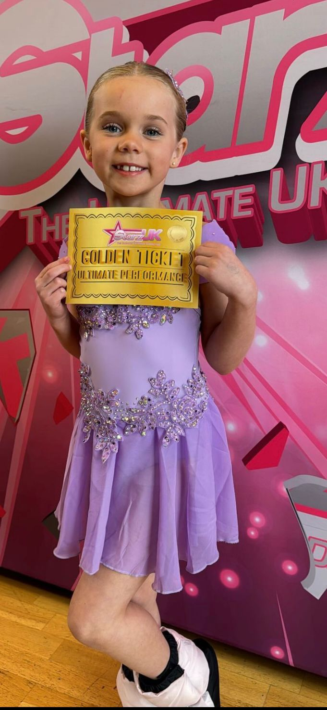

**Sporting Success**

I am pleased to report that Erin B, who is in Mrs Darby’s class in

Year 3, took part in a competition and came 1st in her solo routine

out of 8 competitors, and won 1 of 10 golden tickets given out

throughout the day, with over 160 performances taking place.

In addition, Erin won 1 of 4 judges ‘special mention awards’ for the

day too! Erin also took part in her 5th competition and came 2nd

out of 5 competitors.

Well done Erin; this is amazing news – you are a superstar!

**Parent Questionnaire Results**

You may be aware that at the end of the summer term 2024, we carried out a ‘Parent Questionnaire’. This is an important document which adds to the whole range of self-evaluation procedures which we have in school. The gathering of parental views ensures that we work in partnership with you to recognise our current strengths as a school and any areas where we need to improve. I am pleased to report that we received a high number of responses from parents and will use your feedback to move the school forward. An overview of the results has been sent home today with this newsletter. I hope that you will agree that the overall results reflect the high standards already achieved at Five Ways and that the areas for development, when addressed, will improve our school all the more. Thank you to all those parents who were able to complete a questionnaire and share their views with us so honestly.

**Special Achievements**

At Five Ways, we understand the importance of developing the talents of all children whether in the arts, in sport or academically; we believe that every child should have the chance to shine and be rewarded for their talents. To celebrate our pupils’ successes, we have a display board in the entrance corridor at Five Ways, which shows all the tremendous achievements of our pupils. If your child has achieved something of which we can all be proud, please send a certificate, photograph or explanation of your child’s achievement into school. We will then display it with all our other superb

achievements and publish it in the newsletter for everyone to see. Well done everyone!

**Parent Partnership**

There is a noticeboard close to the school office which provides information to support families with children who have Special Educational Needs. Copies of the booklets that are displayed are available from the school office or can be obtained from Mrs Fuller. Information about courses which parents can attend and activities which pupils with Special Educational Needs can get involve in, are also advertised. Please come and take a look at the information and support available, and do not hesitate to speak to Mrs Fuller if you have any concerns regarding your child, in relation to Special Educational Needs.



**Five Ways Primary School**

Heath Hayes, Cannock, WS12 2EZ

Web Site Address: **www.fiveways-primary-school.org.uk**

Tel No: 01543 278071 Email: [office@fiveways.staffs.sch.uk](mailto:office@fiveways.staffs.sch.uk)

**Five Ways Primary School**

Heath Hayes, Cannock, WS12 2EZ

Web Site Address: **www.fiveways-primary-school.org.uk**

Tel No: 01543 278071 Email: [office@fiveways.staffs.sch.uk](mailto:office@fiveways.staffs.sch.uk)

**PTFA News!**

**PTFA AGM** – Taking place on **Tuesday 1st October at 7.15pm** in the KS1 staffroom. Everyone is welcome! At this meeting, the new committee will be voted in for 2024 – 2025. We look forward to seeing you there!

**Tesco Blue Tokens** – We are extremely pleased to announce that our application to Tesco Stronger Starts has been successful and our project will be put forward to a customer vote in Tesco stores. Voting will commence in store from the first week in October 2024 until Mid-January 2025. Money raised will go towards purchasing play equipment for our Opal project which will improve the physical and social development of children during their

lunchtime period.  
  
The Tesco project with the highest number of votes across our region will

receive £1,500, the second placed project £1,000, and the third placed

project £500.  The following stores are taking part in the voting of on our project:  
Tesco Heath Hayes, Tesco Hednesford, Tesco Express Cannock, and Tesco Express Great Wyrley. Please share this information with your family and friends and ask that the next time they shop at Tesco, that they drop a **blue token** into our pot. Please see attached a flyer sent home today for more information.



**Parents’ Evening**

Parent consultations will take place during the week beginning 14th October with

Parents’ Evening on Thursday 17th October. Appointments will be available to be booked online. You will be sent a link to your mobile phone or email address, which will take you to the online booking system to select a time convenient for you.

Please follow these simple steps to book your appointment:

1. Click the link that you receive through text and/or email to take you to the confirmation page. You will need internet access to do this.
2. Enter your child’s first name to continue. If you have more than one child, any of their first names will work.
3. Next, you will be taken to the booking page. This will show your children alongside the teacher that you need to book in with.
4. Click ‘Please Choose’ to be shown a list of available times that you can click to book.
5. Please click ‘Book this Slot’ to complete your booking. When the button has turned green you know your booking has been made.
6. At any time before Parents’ Evening, you can click the link on your phone or email again to check your booking time.

The online booking service will be available to access from **9.00am on Monday 30th September** until **Thursday 10th October at 4.00pm**. If you do not have internet access, it is still possible to make an appointment through the school office; please ring and discuss   
this with a member of the office staff who will book an appointment for   
you. If you wish to update your email address or mobile telephone   
number, please contact the school office.